ANNUAL TOWN RESIDENTS MEETING

A G E N D A
To: All Members of the Council, Town Clerk, Press and Residents of Ludlow
Contact: The Town Clerk
Ludlow Town Council, The Guildhall, Mill Street, Ludlow, SY8 1AZ
01584 871970
townclerk@ludlow.gov.uk

Despatch date: 12th April 2023

ANNUAL TOWN RESIDENTS MEETING

Residents of Ludlow are invited to attend the Annual Town Meeting to be held
At Ludlow Methodist Church, Broad Street, Ludlow
on Monday 24th April 2023 at 7.00pm

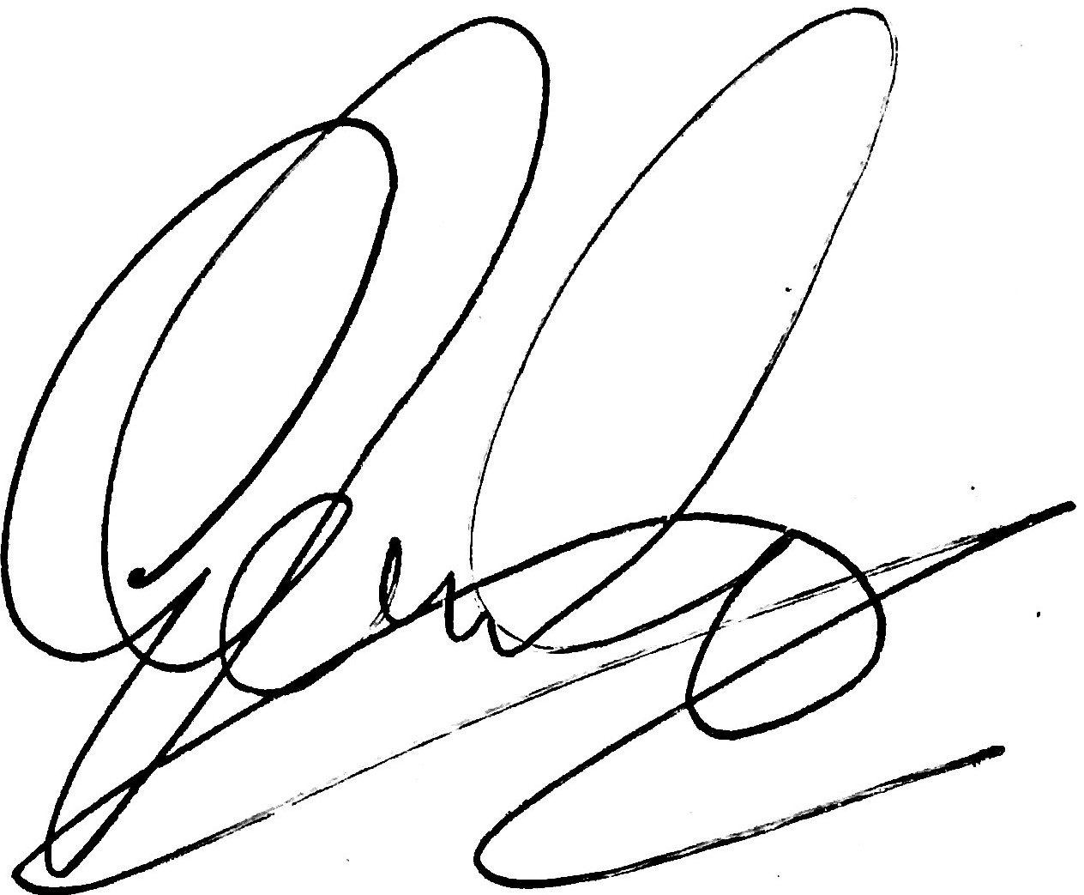

Councillor Glenn Ginger, Mayor of Ludlow

Please join Ludlow’s Town Councillors.
All residents are welcome.

- Welcome from the Mayor
- Annual Report 2022-23
- Questions from Residents

1. Welcome from the Mayor of Ludlow, Cllr Glenn Ginger

2. Apologies

3. Declarations of Interests
The Annual Town Residents Meeting is not a decision-making meeting of the council.

Members are invited to make declarations for transparency and openness.
a) Disclosable Pecuniary Interest
b) Declaration of conflicts of Interest
c) Declarations of personal interest

If a vote is called only Electors of the Town may vote. Attendees at the meeting are therefore advised to check that your name is on the Electoral Register, please ask staff at the meeting. The outcome of any vote at this meeting is advisory only, and will be referred to a future Council meeting.

 | ITEM
5. | WELCOME FROM THE MAYOR
Ludlow Town Council works in support of Ludlow and provides local services in the town.
Councillor Ginger to introduce the Annual Report 2022 / 23.

6. | TOWN COUNCIL LOCAL SERVICES  Committee Chairmen present the work of the Town Council’s Committees.
7. | QUESTION & ANSWER SESSION
 | The public are invited to submit questions, which should be notified to the Town Clerk prior to the meeting. Thank you.

Ludlow Town Councillors
Councillors Ginger (Town Mayor); B. Waite (Deputy Mayor); Adams; Childs; Garner; Gill; Jones; Laurie; Lyle; O’Neill; Parry; Pote, Tapley; Thompson; and S. Waite.

